# **Name: Abdurrahman Qureshi**

# **Roll No: 242466**

Practical No: 2

Date Of Performance: 18/07/2025

Aim: To Perform various GIT operations on local and Remote repositories using GIT Cheat-Sheet

1. Initial Setup: Set your identity for commits

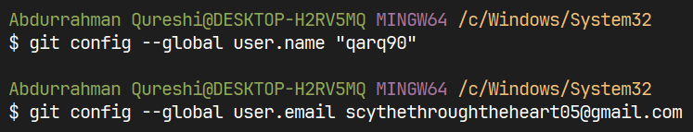

2.Creating Repositories: git init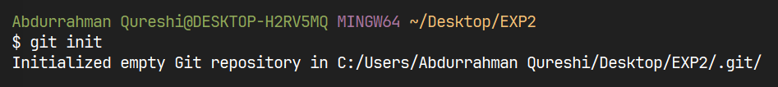

1. Cloning a repo via “git clone <URL>”

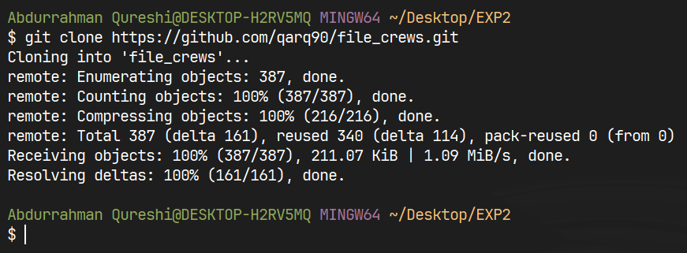

4.Tracking Changes or see current state: git status

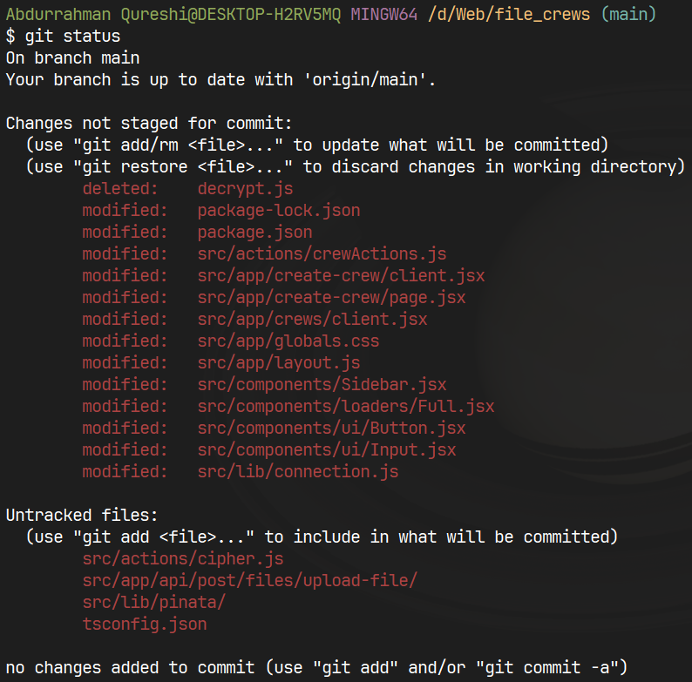

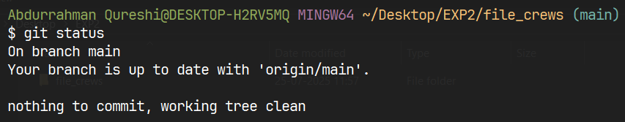

1. Stage files for commit: git add <file>

git add .



1. Commit staged changes locally:

git commit -m "Message"

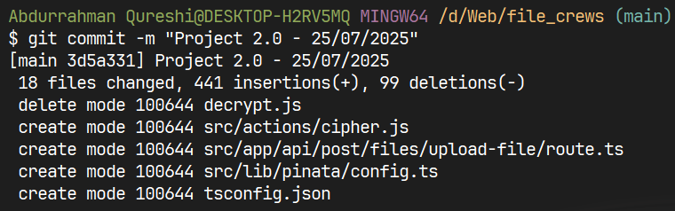

1. Show commit history and Viewing History & Difference:

git log

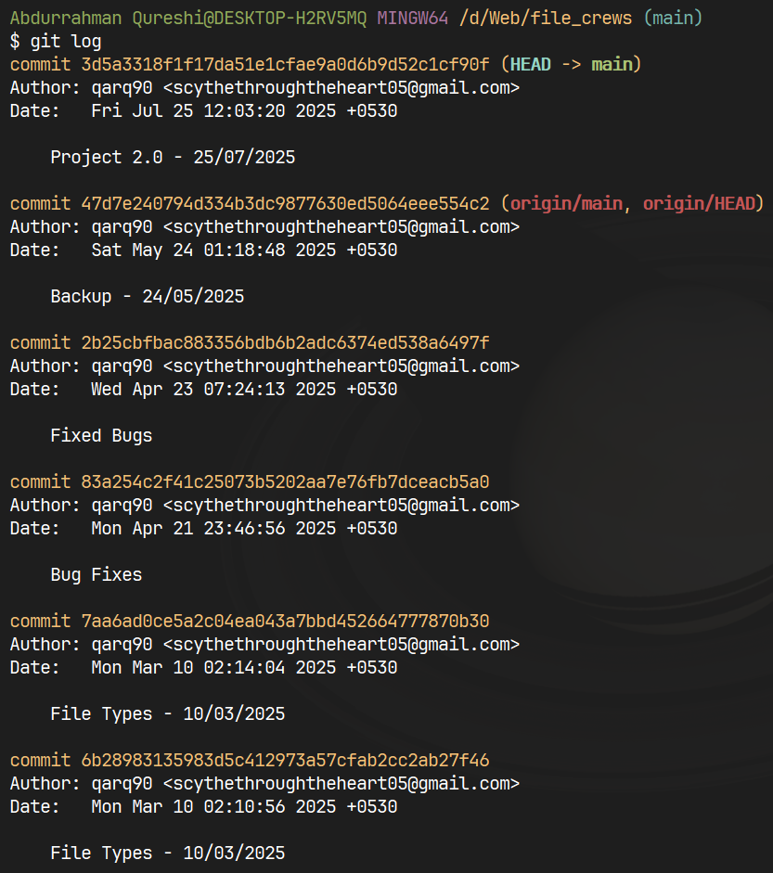

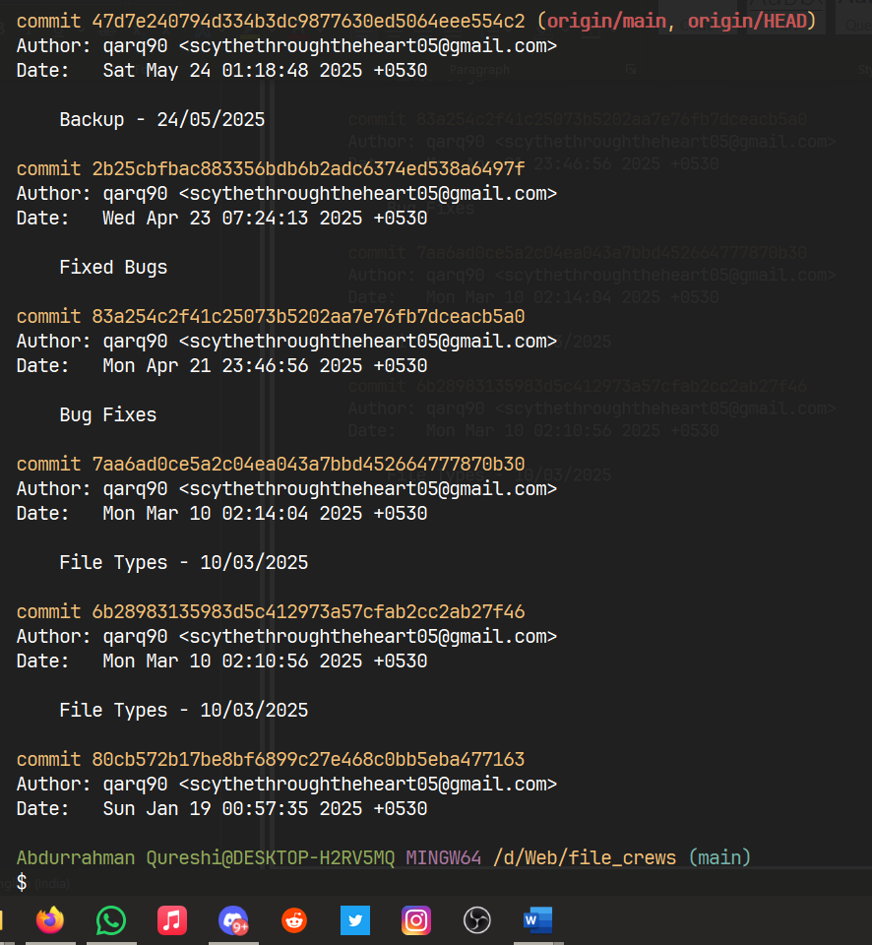

1. Condensed visual history:

git log --oneline --graph

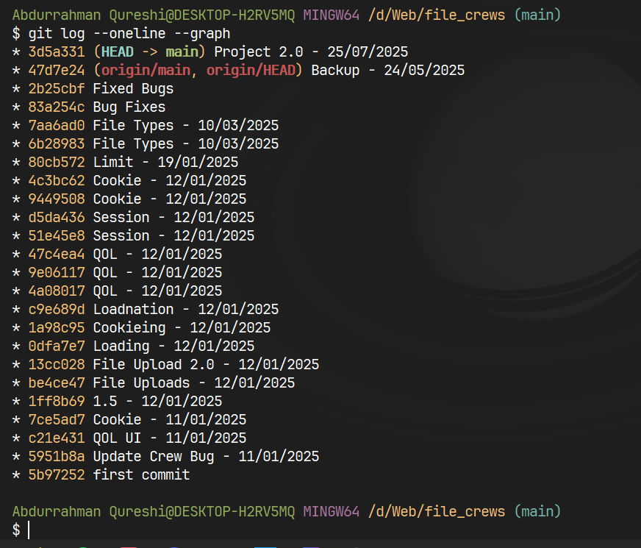

1. Show differences: git diff



10. Show branches: git branch

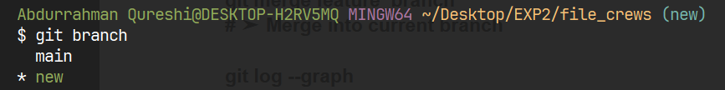

1. Create and switch to new branch:

git checkout -b branch_name

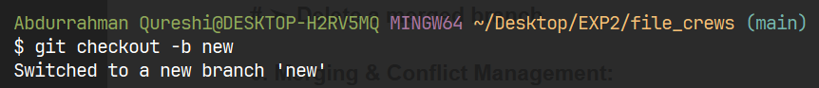

12. Switch to an existing branch:

git checkout branch_name

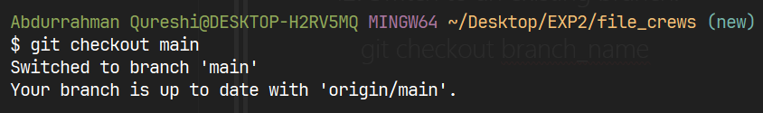

13. Delete an existing branch:

git branch -d branch_name

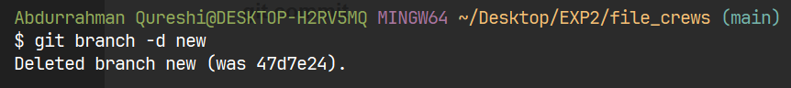

14. Visual confirmation of merge: git log --graph

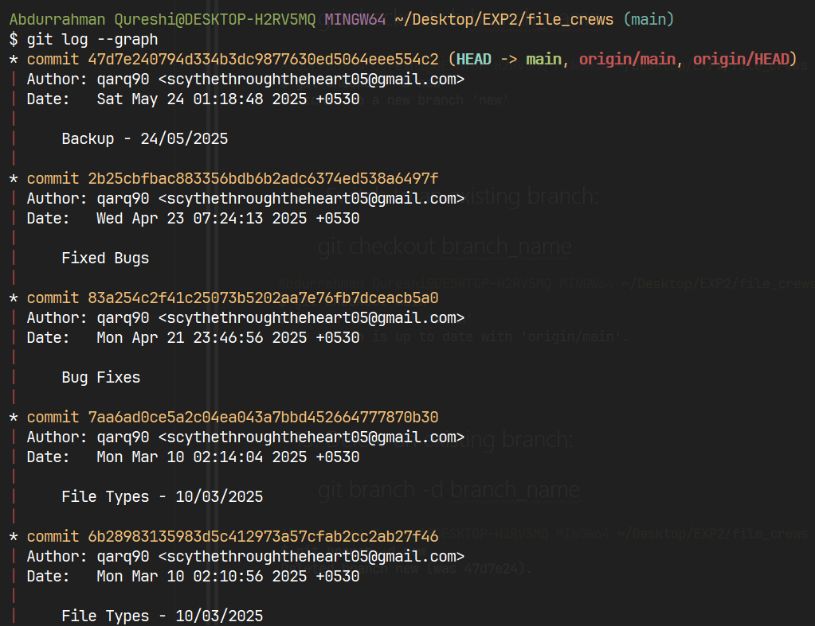

Conclusion:

We performed and understood various GIT operations on local and Remote repositories using GIT Cheat-Sheet.